Data Visualisation II Report

By: Timothy Jordan

**URL link to visualisation**

<https://timjordanre.github.io/DataVisA2_RefugeeData/>

**Domain, Why and Who**

The domain of my visualisation would be Forcibly Displaced People (FDP) around the globe which includes refugees and asylum seekers. It touches upon the continents and nations that reject refugees and grant protection to them, the main reasons why people are forced to migrate, the main causes of death when trying to migrate and where most refugees come from.

The main purpose of my visualisation is presenting information about the journey of FDPs and measure the gravity of the struggles they experience and what discover trends about much continents and nations of different income levels are contributing to host and support them.

My demographic consists of individuals that are interested in refugee and asylum seeker statistics and want to discover more information about the countries that they originate from and the countries that host them.

**What**

Data used within the visualisation is originated from multiple sources:

Author: Paul Mooney,Title: “Latitude and Longitude for Every Country and State”, url: https://www.kaggle.com/datasets/paultimothymooney/latitude-and-longitude-for-every-country-and-state

Author: Andrada Olteanu ,Title: “ISO Country Codes – Global”, url: https://www.kaggle.com/datasets/andradaolteanu/iso-country-codes-global

Author: Natural Earth ,Title: “1:10m cultural vectors”, url: https://www.naturalearthdata.com/downloads/10m-cultural-vectors/

Author: UNHCR ,Title: “Asylum Decisions”, url: <https://www.unhcr.org/refugee-statistics/download/?url=U9N0ym>

Author: UNHCR ,Title: “Population Figures”, url: <https://www.unhcr.org/refugee-statistics/download/?url=K3zeoL>

Author: Chaitanya Gokhale ,Title: “country to continent”, url: <https://www.kaggle.com/datasets/statchaitya/country-to-continent>

Author: The World Bank, Title: “Total Population of Nations”, url: <https://data.worldbank.org/indicator/SP.POP.TOTL?end=2021&start=2021&view=map>

Author: UNHCR, Title: “Refugee Statistics”, url: <https://www.unhcr.org/refugee-statistics/>

Author: Missing Migrants Project, Title: “Missing Migrants Project Data”, url: <https://missingmigrants.iom.int/downloads>

Author: Hamza El Bouatmani, Title: “World countries income class (2020)”, url: <https://www.kaggle.com/datasets/hamzael1/world-countries-income-class-2020>

Author: Maxisonix, Title: “Maxisonix Free Website Template”, url: <https://www.os-templates.com/free-website-templates/maxisonix>

Author: Missing Migrants Project,Title: “Missing Migrants Project Data”, url: <https://missingmigrants.iom.int/downloads>

**Why and How**

Figure 1: Line Chart Global Forcibly Displaced Population

The purpose of this line chart idiom is to instantly communicate the number of forcibly displaced people throughout the years and using the colour channel to easily distinguish between different types of FDPs by users.

Figure 2: Rejection Rate of Refugees by Each Continent

A bump chart is utilised for this dataset to succinctly visualise the ranking between each continent in terms of refugee rejection rate. The use of position channel to show the ranking effectively shows this to the user.

Figure 3: Acceptance Rate of Refugees by Countries

A scatter plot idiom is utilised to present 4 dimensional information using 3 different channels. X and Y positions are used to code the total number of refugee applications and the number of refugees granted protection respectively. The colour channel is used to classify the different dots by continent. The size channel encodes the nation’s population size in the year. A dot plot allows use to visualise dense information about refugee acceptance rate by each country in a concise manner easy for users to digest. Added interactivity in using the year selection

Figure 4: connected Bubble plot and line chart

A bubble plot idiom is utilised to present dense information from the small range of categories (cause of deaths) and the size channel is used to measure the number of deaths. An line chart to filter to different time ranges makes for an intuitive interactive feature for users.

Figure 5: Chroropleth map

The choropleth map in figure 5 is used to easily identify the refugee density of various countries. Without requiring to read information, users can easily compare two different nations based on the difference in colour hue. Added annotation to each significant nation allows readers to absorb information without needing to use the tooltip

Figure 6: Faceted Bar Chart

A faceted bar chart shown in figure 6 allows users to find specialised information about the origin nation. Colour channel is cleverly used to highlight the income group of nations. A red horizontal rule mark is used to encode the average number of refugees taken per population.

**Design**

Layout

The visualisation is laid out in a traditional and conventional format where information is being displayed from top to bottom and left to right. Colour and whitespace is expertly used to cluster relevant information to different idioms

Colour

Figure 7: Using colour to highlight important information and segregate text



Figure 8: Using colours continuously

Two shades of a minimalistic colour is used (shown in figure 8) as the background colour of the visualisation to make text and idioms stand out more. These two shades are cleverly used to segregate and group sections of content without using unnecessary whitespace. A bright red shade of red is also used to highlight key info from the visualisation and unique qualitative colours are continuously used throughout to identify continents.

Figure-ground

Grey is used in choropleth map (figure 10) to place useful info in the foreground while keeping unnecessary parts in the background. The legend selection in figure 9 uses the opacity channel to highlight the section for the use and makes the other parts transparent, placing them in the background.

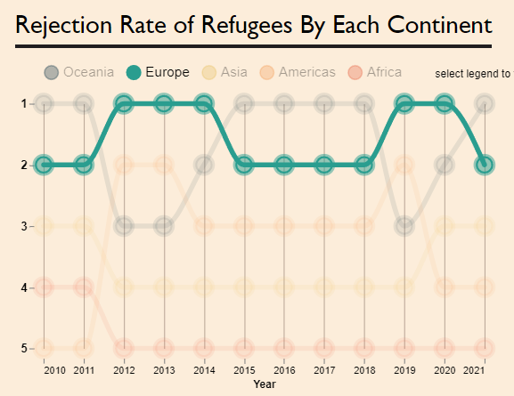

Figure 9: legend selection

Typography

Typography is used to create a visual hierarchy of information. Users can easily categories groups of information and determine the importance of the text based on the size, weight, colour and added border. A sans serif font family is used throughout to maintain consistent. Gill Sans MT is used for the headers, while the smaller font size text uses Arial to aid in readability.

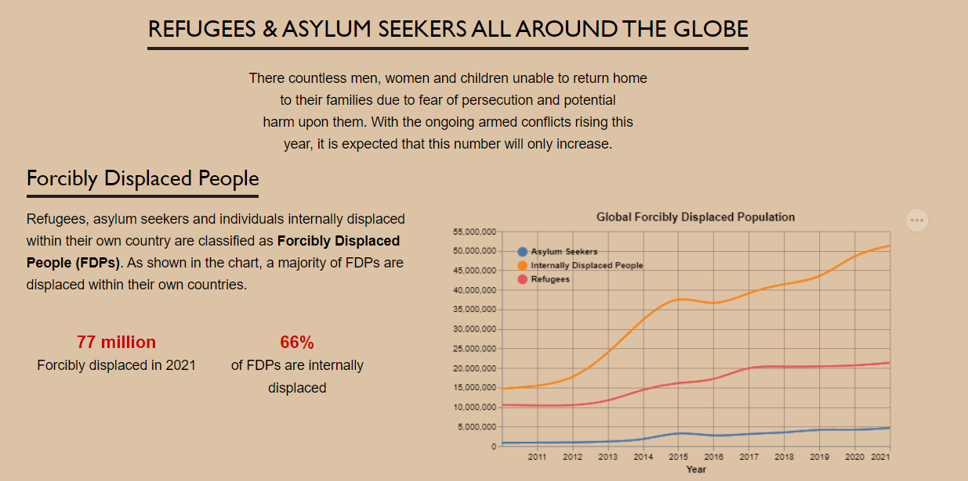

Figure 10: Visual hierarchy created from typography

Storytelling

The contents and idioms of the visualisation is laid out to initially focus on the large scale areas of the topic considering all refugees globally and continentally. The focus then narrows down to information about specific nations and countries.

**References**

*‘country to continent’*, n.d., viewed 17 October 2022, https://www.kaggle.com/datasets/statchaitya/country-to-continent.

*‘Download Missing Migrants Project data | Missing Migrants Project’*, n.d., viewed 17 October 2022, https://missingmigrants.iom.int/downloads.

*‘Latitude and Longitude for Every Country and State’*, n.d., viewed 17 October 2022, https://www.kaggle.com/datasets/paultimothymooney/latitude-and-longitude-for-every-country-and-state.

*‘Maxisonix Website Template | Free Website Templates | OS Templates’*, n.d., viewed 17 October 2022, https://www.os-templates.com/free-website-templates/maxisonix.

*‘Population, total | Data’*, n.d., viewed 17 October 2022, https://data.worldbank.org/indicator/SP.POP.TOTL?end=2021&start=2021&view=map.

Refugees, UNHC for, n.d.-a, ‘2015: The year of Europe’s refugee crisis’, UNHCR, viewed 17 October 2022, https://www.unhcr.org/news/stories/2015/12/56ec1ebde/2015-year-europes-refugee-crisis.html.

Refugees, UNHC for, n.d.-b, ‘UNHCR - Refugee Statistics’, UNHCR, viewed 17 October 2022, https://www.unhcr.org/refugee-statistics/.

*‘The State of Renewable Energy’*, n.d., viewed 17 October 2022, https://cauchy2criterion.github.io/FIT3179-Assignment2/.

Welle (www.dw.com), D, n.d., ‘Germans less skeptical of immigration | DW | 16.02.2022’, DW.COM, viewed 17 October 2022, https://www.dw.com/en/germans-less-skeptical-of-immigration/a-60801783.

*‘World countries income class (2020)’*, n.d., viewed 17 October 2022, https://www.kaggle.com/datasets/hamzael1/world-countries-income-class-2020.